- Published 2015-12-06
HI5ives! Hostel Awards 2016 Winners announced
It’s that time of the year again and we are very proud to announce the winners of our hostel awards. Big congratulations to the staff of these amazing hostels, now let’s see who the winners are…
Best hostel: Hi Seoul Youth Hostel, HI South Korea
Located in the heart of Seoul, this state-of-the-art hostel has everything to offer. From cutting-edge facilities, including an auditorium, conference rooms, a coffee shop, resting room and modern self-catering facilities to some of the friendliest staff to be found in a hostel. It’s no surprise that this hostel that opened in 2011 excels at customer satisfaction as one of the most modern properties of the HI network. A much-deserved award for an all-round hostelling experience in vibrant Yeongdeungpo.
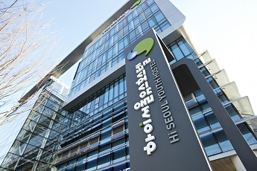 |  | 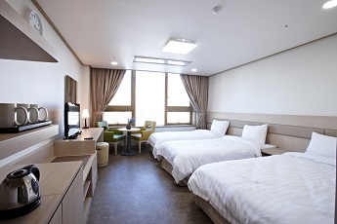
- 2nd place - HI-Richmond, HI USA
3rd place - Reykjavik Downtown, HI Iceland
To see the top 20 in each category, click here
Friendliest hostel: Hi Seoul Youth Hostel, HI South Korea
Hi Seoul Youth Hostel crowns a wonderful year by taking the Friendliest hostel award. The staff here go the extra mile to create an unforgettable experience for each guest. From a welcoming check-in to a number of activities for individuals and groups, this hostel has become a favourite and reached an impressive and near-perfect 99% rating on friendliness.
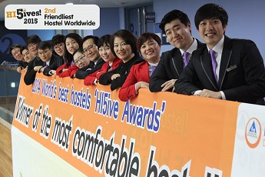
2nd place – HI-Martha’s Vineyard, HI USA
3rd place - Hangout@mt.emily, HI Singapore
To see the top 20 in each category, click here
Most comfortable hostel: Hi Seoul Youth Hostel, HI South Korea
Hi Seoul Youth hostel sweeps up a third award this year for Most comfortable hostel! Being comfortable starts with a cosy bed and they know that better than anybody else. They have excelled at offering a home away from home for all their guests, be it in the rooms or in the lounge areas.
Room Photo
2nd place - HI-Richmond, HI USA
3rd place - Hangout@mt.emily, HI Singapore
To see the top 20 in each category, click here
Green hostel: HI-Portland Hawthorne Hostel, HI USA
HI Portland Hawthorne Hostel has done it again… With a 97% Green rating they have achieved the Green hostel award for the second year in a row! They not only offer a perfect solution for the responsible traveller but also educate the local community with a number of year-round initiatives aimed at looking after climate and local surroundings.
2nd place - Reykjavik Downtown, HI Iceland
3rd place – Kyoto – Utano Youth Hostel, Japan Youth Hostels
To see the top 20 in each category, click here
Best HI Hostel network: HI Singapore
HI Singapore’s achievement reflects the rising importance of hostels in the Asian markets. They have shown commitment for excellence and won over their travellers by offering green-friendly accommodation, superb security, outstanding cleanliness and all in excellent locations. The best thing, a staff ready to go above and beyond to make sure guests have a stay to remember.
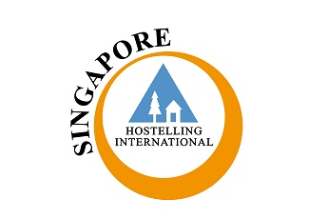
2nd place - HI USA
3rd place - YHA Hong Kong
To see the other top ranked Hostel associations, click here
Congratulations again to all the hostels for achieving outstanding customer satisfaction; keep up the good work and encouraging your customers to rate and review the hostel if they liked it, on hihostels.com.
All awards were based on customer ratings received during a 12-month period, from 1st November 2015 to 31st October 2016. During these 12 months, a minimum of 60 reviews per hostel for single hostel categories was required to qualify, and a minimum of 20.1 reviews per hostel for the Best HI Hostel Network category. The average of reviews per hostel for the period was of 20.1. In case of a tie, the winning hostel is the one with firstly, the best overall rating and secondly, the most reviews. For best country only full HI Member Associations are eligible.

