보도자료
2016. 12. 29.(목)
 | 담당자 | 최정훈 기획국장
 | 연락처 | (☎02-725-3031/010-3919-3136
 | ■ 총 19쪽

“뉴질랜드 자유여행, 유스호스텔 국제회원증으로 다양한 여행상품 할인 이용”
- Kiwi Experience National Passes $50 할인, Kathmandu 여행상품 20% 할인, ACE Car Rental 10% 할인, Hertz Car rental 10%할인

한국이 겨울이면 뉴질랜드는 여름이다. 금빛 모래 해변에서 수영복을 입고 해수욕을 하는 이런 즐거움을 만끽하기 위해서 우선 뉴질랜드로 비행기 타고 go go!

유스호스텔 국제회원증으로 뉴질랜드 40개의 유스호스텔 할인 이용 외에도 ACE Car Rental, Hertz Car Rental 10% 할인 및 다양한 여행상품 할인의 특혜를 받아보자. 우선 버스관광상품인 키위 익스피리언스http://www.kiwiexperience.com/ 의 버스패스는 50 뉴질랜드달러 할인을 받을 수 있고 카트만두http://www.kathmandu.co.nz/의 모든 여행상품을 20% 할인하여 이용할 수 있다. 오클랜드지역으로 여행에는 Auckland Adventure Duck 투어를 1인당 15 뉴질랜드달러, Auckland Adventure Jet은 25뉴질랜드달러, Auckland Explorer Hop-on Hop-off Bus는 10뉴질랜드달러, Auckland Travel Clinic 10% 할인하여 이용할 수 있다.
스카이다이빙을 즐기는 여행자는 Skydive Auckland $30 off any camera package, Skydive Bay of Islands 10% off any camera package를 이용해보자.

Hachei Beach 해안동굴의 카약투어를 체험해보고자 하는 여행자는 Cathedral Cove Kayak Tour http://www.seakayaktours.co.nz/ 이용시 훼리에서 카약체험장까지 교통편을 지원받을 수 있고, Kaituna Cascades Raft and Kayak Expeditions http://kaitunacascades.co.nz/ 은 $10 off rafting plus $10 off photo CD의 혜택, Raftabout Whitewater Rafting and Sledging http://www.raftabout.co.nz/ 은 15% 할인 혜택을 받을 수 있다.

유스호스텔 국제회원증은 유스, 어덜트, 패밀리, 리더, 그룹으로 구분 발급되고 유효기간은 6개월, 1년, 2년, 3년, 4년, 5년 및 평생을 선택할 수 있다. 특히 금년 12월부터는 핸드폰에 유스호스텔 국제회원증을 다운로드 받아 이용하거나 종이 인쇄하여 사용할 수 있는 e-membership이 개발되어 사용할 수 있다. 회원증 비용은 성인기준(어덜트) 1년제는 실물카드 기준 33,000원에서 e-membership기준 17,000원으로 인하하였고 유효기간의 6개월의 회원증을 신규개발하여 12월부터 제공하고 있으며 11,000원이다. 실물카드를 원하시는 분은 5천원을 추가하면 된다.
한국유스호스텔연맹 문의 (02)725-3031. www.kyha.or.kr

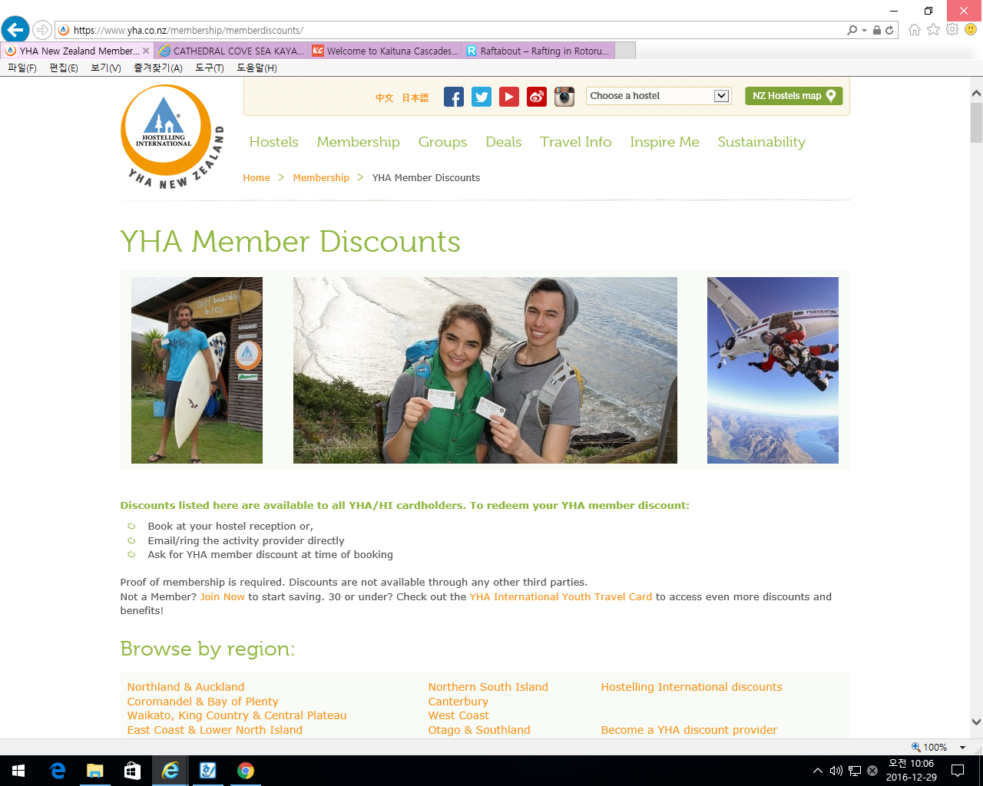

뉴질랜드 할인혜택현황

Nationwide

ACE Car Rental
Save 10% with promo code YHA
17 locations across Australia and New Zealand
0800 502 277 or Book online

Cover-More Travel Insurance
Special rates on travel insurance when purchased through YHA New Zealand
0800 278 299 Contact us
CM YHA NZ Web Banner Hiker 728x90

Europcar
5% off Europcar Australia and New Zealand rentals
Book online

Hertz
10% off best available rental car rates for YHA members
Simply quote the Customer Discount Programme (CDP) number 2078180
Book online

InterCity
Discounted backpacker fares for YHA members (selected services only)
09 583 5780 or Book online

Kathmandu
YHA Members receive 20% off Kathmandu branded travel and adventure gear when you join the Summit Club for free (usually $10)
Terms and conditions apply
0800 001 234
Kiwi Experience
$50 of all National Passes for YHA members
09 336 4286

Lonely Planet
20% off retail price on all Lonely Planet publications when purchased through YHA New Zealand National Office.
Browse popular titles or to request a particular title, freephone 0800 278 299

Omega Rental Cars
Special Rates for YHA members
0800 525 580

Spaceships
1 free day's hire when booking 14 or more days (offer must be quoted at time of booking)
0800 772 237

Stray Hop-on Hop-off Bus Network
Free Bay of Islands Jack Pass with any National Pass (offer must be quoted at the time of booking and is not valid with any other deal)
09 526 2140

Wilderness Magazine
YHA members receive a discounted 12 month subscription rate of $79. Saving $10.50 per year!
Email YHA with your membership number for your discount code to order online

Northland & Auckland

Adventure Cycles
We hire, sell and service all types of bicycles, accessories and trailers
10% off all purchases except WWOOF books
Western Springs, Auckland. 0800 2453 868 or email

Auckland Adventure Duck
Save $15 per person on an Adventure Duck amphibious tour
0800 382 528 or email

Auckland Adventure Jet
$25 off our adrenaline pumping jet boat tour with Auckland Adventure Jet
0800 255 538 or email

Auckland Explorer Hop-on Hop-off Bus
Save $10 on an Adult Day Pass and explore Auckland city at your leisure
0800 439 756 or 0800 4 EXPLORER

Auckland Travel Clinic
10% off consultation fees for travelers' health and vaccinations
09 373 4621

Auckland Whale & Dolphin Safari
World-class wildlife in Auckland! Receive 20% discount with code YHAMAP
08508 DOLPHINS (365 744)
Byron International Group Ltd.
10% off on driver's license translations for most languages (NZTA approved).
Auckland, 09 368 1588 or email

Covo Pasta Pizza Bar
20% discount if you purchase any item between 11am - 2pm and 5pm - 6pmGo Skydiving with YHA and Skydive Auckland
09 377 9290

Dive Tutukaka
FREE lunch! Who says there is no such thing?
0800 288 882

Explore NZ (Auckland)
Up to $31 off excursions departing Auckland
0800 397 567

Fullers GreatSights
10% discount on selected tours and cruises
0800 653 339

Skydive Auckland
$30 off any camera package
0800 921 1650

Skydive Bay of Islands
10% off any camera package
0800 465 876

Coromandel & Bay of Plenty

Agroventures
10% discount on all rides and packages. Not valid for group bookings or Agropasses
FREE transport available by request
07 357 4747

Cathedral Cove Kayak Tours
Free return transport from Ferry Landing (save $10!)
0800 529 258 (within NZ) or +64 7 866 3877

Coromandel Nature ToursGo Rafting with Kaitiaki Adventures and your YHA members discount
Small Group and Custom Tours (German, English, Japanese) from Whitianga
10% discount on our Hobbiton Tour M203 (save up to $27)
07 867 1381

Hell's Gate and Wai Ora Spa
10% discount on any Hells Gate packages
07 345 3151

Kaitiaki Adventures
Half price photos with every YHA booking - save $17.50!
0800 338 763

Kaituna Cascades Raft and Kayak Expeditions
$10 off rafting plus $10 off photo CD (discount applies to full retail price)
0800 KAITUNA

Mitai Maori Village
Receive one complimentary wine/beer or non-alcoholic beverage per person booked
07 343 9132

Mamaku Blue Blueberry Experience
New Zealand’s only Blueberry tourism experience.
FREE $6.00 Blueberry Jelly or Chilli with a $50.00 purchase from our shop or cafe
Rotorua, 07 332 5840

Off Road NZ
10% off Off Road NZ Packages (offer is subject to availability and is not available with any other offer)
07 332 5748

Paradise Valley Springs Wildlife and Lion Park
10% discount off full adult and child admission prices
not valid with any other offer
07 348 9667

Raftabout Whitewater Rafting and Sledging
15% discount on rafting and guided kayaking
0800 RAFTABOUT (723 822) or 07 343 9500Take in the sights from Rotorua's Gondola with your YHA discount

NZ River Jet "The Squeeze"
$20 p.p. off or free photo pack valued at $25
0800 748 375 or 07 333 7111

Skyline Rotorua
10% discount on retail Gondola rides
07 347 0027

Tamaki Maori Village
Book at YHA reception for a special $99.00 rate! Normally $120

Te Puia
10% discount on all Te Puia products (can not be used in conjunction with other offers)
07 348 9047

Waimangu Volcanic Valley
The world’s newest hot water springs
10% discount on self-guided walks & hikes, & boat cruise
07 366 6137

Wet n Wild Rafting Company
10% off Regular Prices for Kaituna, Wairoa, Rangitaiki Rivers
0800 462 723

Waikato, King Country & Central Plateau

Hukafalls Jet
10% discount on the Hukafalls Jet
0800 HUKA JET

Mountain Bike Station
20% off our services for all mountain bike rental and transportation to the Ohakune Old Coach Road trail
(excluding outside operator services)
0800 385 879 or 06 385 8797

Rafting New Zealand
10% discount off our Tongariro White Water Adventure
0800 865 226

Raglan Boat Charters - Wahine Moe Cruises
50% discount on public sunset cruises (normally $49.00, YHA members only $25)
07 825 7873

Raglan Surfing School
10% discount on surfing lessons and equipment hire
07 875 7873Ride the Ohakune Old Coach road trail with your YHA member discount
Rapid Sensations Ltd
10% discount on kayaking to Maori Rock Carvings. Minimum numbers 2 adults
07 374 8117

Sail Fearless
YHA members receive 20% off any of our Daily Sailing Tours to the Maori Rock Carvings onboard "Fearless"
022 189 1847 or email sailfearless@hotmail.com

Skydive Taupo
10% off personalised freefall videos and photos
0800 373 335

Taupo Bungy and Cliffhanger
Two awesome activities, one stunning location - Bungy Jump & Extreme Swing.
Save $20! Bungy jump for $149 or Extreme Swing for $125! Valid to 31 October 2017.
0800 888 408 or 07 377 1135

Taupo Tandem Skydiving
10% off any camera package
We jump 7 days a week, 362 days a year. Free pick up available
0800 826 336

The Legendary Black Water Rafting Co
10% discount for all YHA members
0800 228 464, 07 878 6219
Tongariro Quads
FREE photos worth $50 with any ride.
07 378 2662

East Coast & Lower North Island

BATS Theatre
Concession rates for YHA members $12 - $15 tickets
04 802 4175

Fishbike
10% off half and full day Fishbike
Bicycle Rentals, Marine Parade, Napier
06 833 6979

Wellington Rover Tours
Book a tour with us and receive $20 off any other tour
04 471 0044

Wellington Zoo
$16 entry when you show your YHA membership card
04 381 6755

Zealandia Eco-Sanctuary, Wellington
$14 general admission for YHA members
Ph 04 920 9200

Northern South Island

Abel Tasman Kayaks
10% off Abel Tasman Kayaks kayaking trips. Not valid on public holidays.
03 527 8022

Abel Tasman Skydive
$20 off a tandem skydive for YHA members
0800 422 899

Abel Tasman Wilsons Experience
10% YHA cardholder discount off retail, for any of our day or multi-day trips
0800 223 582

Beachcomber Cruises
10% discount off all products for YHA members
03 573 6175

E-Ko
Environmental, Kiwi Owned – E-Ko – Marlborough’s wildlife and dolphin experts.
10% off any of our adult fares, direct bookings only
03 573 8040

Sea Kayak Adventures Anakiwa
Kayak, Bike, Walk - Go outside and do something you’ll remember!
$10 off any guided sea kayak tour or $5 off kayak rental
0800 262 5492

Canterbury & Northern Otago

Air Safaris & Services (NZ) Ltd
10% off famous 50 min "Grand Traverse" of Mount Cook & Glaciers
0800 806 880

Akaroa French Connection
YHA card holders $5 off Christchurch - Akaroa - Christchurch return fare
0800 800 575

Albatross Encounter Kaikoura
Free muffin and hot beverage from the cafe for YHA members at the conclusion of the tour
0800 733 365

Alpine Sports Methven Mt Hutt
10% off ski/board hire when you present your YHA Membership

Black Cat Cruises
10% off Akaroa Harbour nature cruise or swimming with the dolphins - Akaroa
The only place on the planet where you can swim with Hectors Dolphins - the world's smallest and rarest Dolphins
Use discount code YHA10 to redeem online
0800 436 574 or email akaroa@blackcat.co.nz

Dolphin Encounter Kaikoura
Free muffin and hot beverage from the cafe for YHA members at the conclusion of the tour
Use your YHA membership for great discounts!0800 733 365

Glacier Sea Kayaking
$5 discount off our Glacier Kayaking Trips (seats limited)
Tasman and Mueller Glacier Lake
03 4351 890

Glide Omarama
10% discount to YHA members for any flight over half hour duration
when booked directly with our Southern Soaring office
0508 58 55 88

Hot Tubs Omarama
Private - Peaceful - Pure Mountain Water
10% discount for YHA members (not to be used in conjunction with any other deal)
03 438 9703

Immigration Express Christchurch
$10 off a full immigration medical for YHA members
03 377 1585
Seal Swim Kaikoura
10% discount on adult seal swimming tours
0800 SEALSWIM (0800 732 579)

Shoestring Rentals
10% discount on car hire or free upgrade.
0800 266 607 or 03 352 4222.

Skydiving Kiwis
FREE $50 voucher towards photo or DVD options.
0800 359 549, 022 101 1537

Skydivingnz
Free T-shirt with a 12,000ft skydive and Freefall Max.
0800 NZSKYDIVE

Te Ana Ngai Tahu Rock Art Centre
Explore ancient Maori cave drawings with local Maori guides at Te Ana
10% discount on Te Ana Maori Rock Art Site Tour

Tekapo Springs
Present your YHA membership card for a free upgrade to our steam and sauna rooms
03 680 6550

The International Antarctic Centre
$5 off single entry tickets for YHA members
03 353 7798

West Coast Shuttle
Christchurch to Greymouth and back again
YHA members receive 10% off a full fare
03 768 0028

YMCA Adventure Centre
The South Island's largest indoor climbing gym and New Zealand's best!
10% discount on climbing wall entry for YHA members.
Christchurch, 03 377 3000

West Coast

Cave Rafting, Glow-worms & Zipline Adventure - Greymouth
FREE zipline thrillseeker flight with cave tour - save $45 (conditions apply)
Direct bookings on 0800 143 724

Fox Glacier Guiding
$10 off Flying Fox; Heli Hike for YHA members
0800 111 600556

On Yer Bike Adventures Ltd
10% off all quad bike and go-kart tours
0800 669 372
Skydive Franz
Free gift worth $29 when you jump with Skydive Franz
0800 458 677

The Helicopter Line
Save $10.00 on Franz Josef Heli Hike
0800 807 767

Underworld Adventures, SH6 Charleston
10% discount on Underworld Rafting and Glow Worm Cave Tour bookings
03 7888 168 or 0800 116 686

West Coast Shuttle
Christchurch to Greymouth and back again
YHA members receive 10% off a full fare
03 768 0028

Otago & Southland

Air Safaris & Services (NZ) Ltd
10% off famous 50 min "Grand Traverse" of Mount Cook & Glaciers
0800 806 880

Appellation Central Wine Tours, Queenstown
Indulge your passion for wine on our daily wine tour with lunch included.
5% discount on our Boutique Wine Tour for YHA members.
03 442 6920 or email bookings@appellationcentral.co.nz

Aspiring Guides
Mountain Guiding in NZ. Ascents, Courses, Ski Tours & Wild Walks.
Free equipment hire for YHA members when booked through YHA New Zealand or directly with Aspiring Guides.
Current YHA membership must be shown on arrival.
03 443 9422

Canyoning Queenstown
Get ready to jump, slide, abseil and zip line through some of the most amazing natural settings New Zealand has to offer
$10 off Queenstown Canyon and $20 off Routeburn Canyon
03 441 3003

Use your YHA membership for great discounts!

Coronet Peak Tandem Paragliding & Hang Gliding
$10 discount with every tandem paraglide or hang glide
0800 467 325.

Dart River Funyaks
FREE Dart River Jet T-shirt per person booked
0800 746 868

Dart Stables
Beautiful horse riding in Stunning Glenorchy
$10 off the "Hobbits Hack"
0800 474 3464 or email info@dartstables.com

Deep Canyon
$20 off Deep Canyon day trips when you present your YHA card
Direct bookings only
03 443 7922

Dunedin Railways
20% discount on Tairei Gorge Railway for YHA members
03 477 4449

Eco Tours
10% discount
0800 900 121

Elm Wildlife Tours
$10 off all tour options
0800 356 563

Fiordland Cinema
Boutique cinema screening 'Ata Whenua' on the hour, most hours.
10% off admission to 'Fiordland on Film - Ata Whenua' - voted a must see!
03 249 88 44
Go Orange
15% discount off all kayak and cruise products in Milford and Doubtful Sound
0800 505 504

High Country Horses
$10 off the Rees River Trail
03 442 9915 or email info@high-country-horses.co.nz

KJet Queenstown
A must-do jet boating experience; Lake Wakatipu, Kawarau & Shotover Rivers.
15% off full retail rate for YHA members. Use promo code YHA15
03 409 0000 or email bookings@kjet.co.nz

Milford Sound Scenic Flights
10% discount per person
0800 207 206

Mitre Peak Cruises
Save 10% on all Milford Sound cruise options
0800 744 633Great discounts for YHA members

NZONE Skydive Queenstown
Free gift to the value of $15 with your tandem skydive
03 442 5867

Queenstown Combos
Save $10 per person on Shotover Heli-rafting
0800 423 836

Queenstown Wine Trail
$5 discount on the "Original Wine Trail", includes a full afternoon of wine tasting
0800 827 8464.

Real Journeys
YHA members are entitled to a 10% discount on the following adult rates:
Milford Sound
Daytime & Overnight Cruise incl. Te Anau / Queenstown coach connections
Doubtful Sound
Daytime & Overnight Cruises incl. Te Anau / Queenstown coach connections
Te Anau
Te Anau Glowworm Caves
Queenstown
TSS Earnslaw Steamship Cruises
Walter Peak Farm Tours
Walter Peak Gourmet BB dining
0800 656 501

Shotover Canyon Swing
Free nerve-calming supplement with your swing.
0800 279 464

Skippers Canyon Jet
One free photo pack for YHA members
0800 226 966

Skydive Lake Wanaka
Free gift with every tandem skydive fro YHA membeUse your YHA membership for great discounts!rs
0800 786 877

Skydive Paradise
Save $10 on your skydive at our Paradise Dropzone, pick up Queenstown
0800 475 934.

Southern Adventure
15% off outdoor clothing and equipment (excludes food, specials and sale items).
31 Tay Street, Invercargill
03 218 3239

Southern Discoveries
10% off Milford Sound Nature Cruises
10% off Spirit of Queenstown Scenic Cruise
0800 264 536 or 03 441 1139

Speight's Brewery Tours
10% off all shop merchandise
03 477 7697

Stewart Island Experience
YHA members are entiled to a 10% discount on Stewart Island return ferry services
0800 000 511

Stewart Island Water Taxi & Eco Guiding
10% discount on water taxi trips
Readily accessible by ferry, Stewart Island is New Zealand's ultimate eco-tourism destination
03 219 1394

Takitimu Tiki Tours Te Anau
10% off our tour of Te Anau
0800 342 342

Trips & Tramps
Save 10% on any Milford or guided walk trip
0800 305 8077

Tuatapere Hump Ridge Track
One free shower with our Hump Ridge Track Walk Package
0800 HUMPRIDGE

Via Ferrata Queenstown
Clip. Climb. Explore.
$10 discount on 1/2 day climbing trips - normally $179
03 441 3003

Wanaka Helicopters
10% off all Wanaka scenic flights and 'O-Fly' exclusive
03 443 1085

Ziptrek Ecotours
Come ziplining in Queenstown and receive $10 off per person
0800 ZIPTREK (947 873)

